**Automating S3 Bucket by using cloud formation**

**Step 1: Template for creation of S3 bucket by using yaml script:**

Properties: {BucketName: "jantt-client"}---

Resources:

  MyS3Bucket:

    Type: "AWS::S3::Bucket"

    Properties: {BucketName: "jantt-client"}

**Step 2: Creating stack-name:** **automatings3bucket using yaml script.**

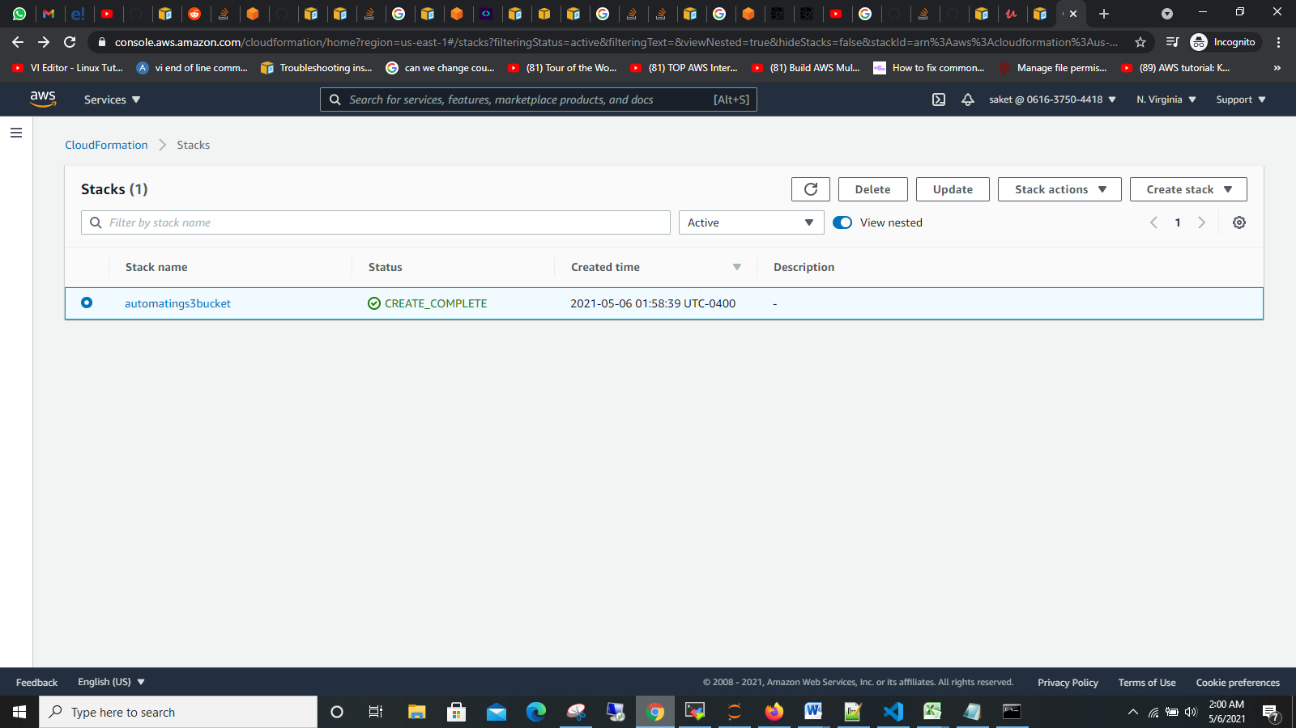

**Step 3: Inside stacks we can see the automatings3bucket stacks info.**

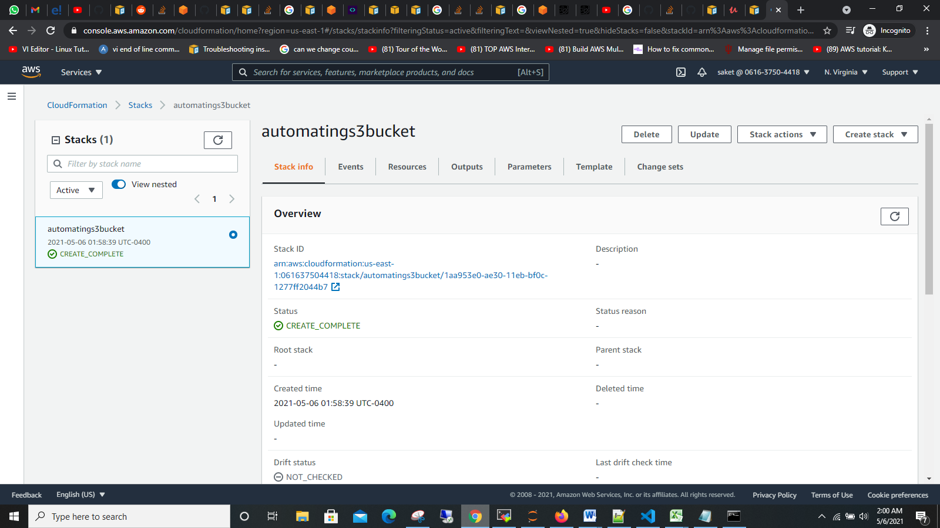

**Step 4: In the stacks we check status of events if it failed status will show in rollback sign. But in our case events are created**

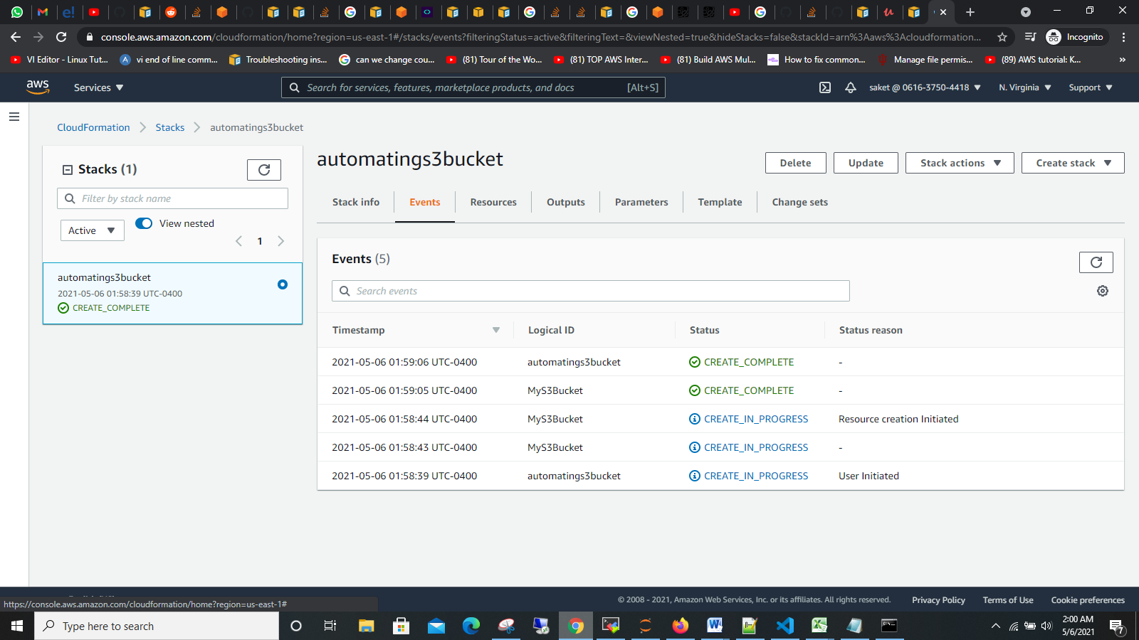

**Step 5: In Stacks we can check what kind of resources are created in our case “jantt-client” and Type – “AWS::S3::Bucket” is created.**

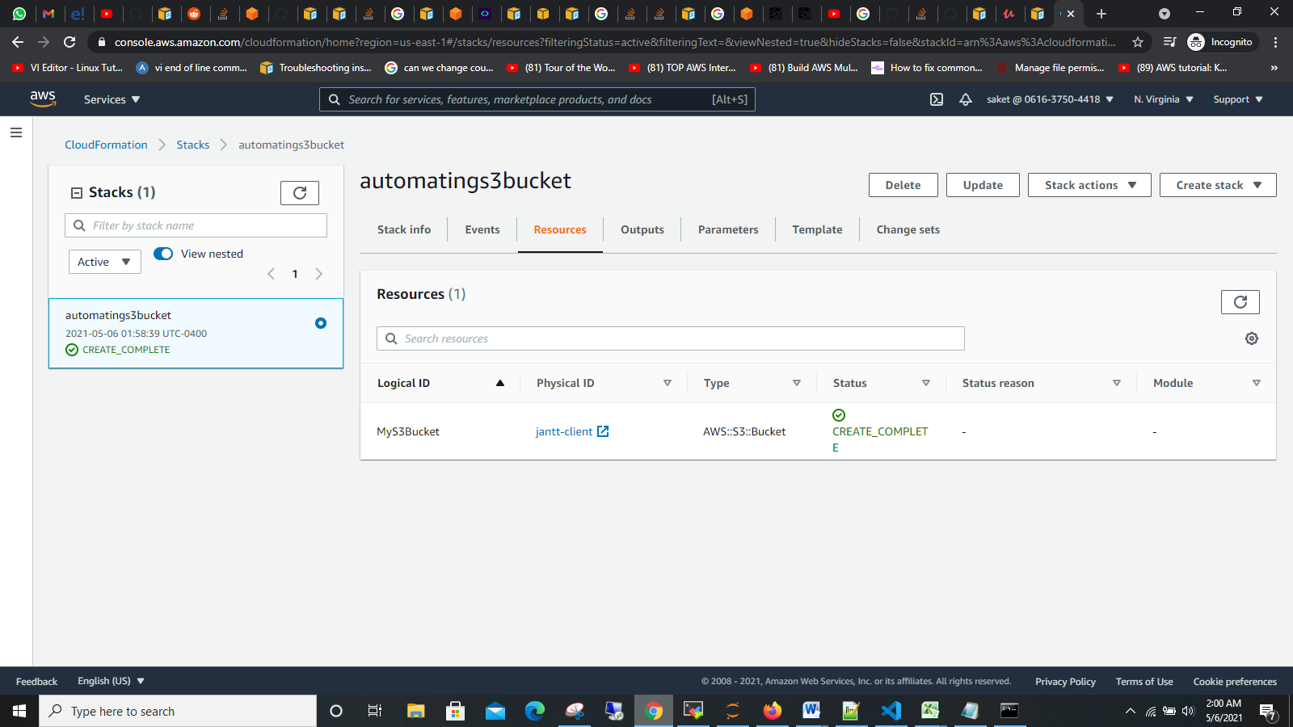

**Step 6: we can check in s3 that s3bucket on name jantt-client is created through cloud formation.**

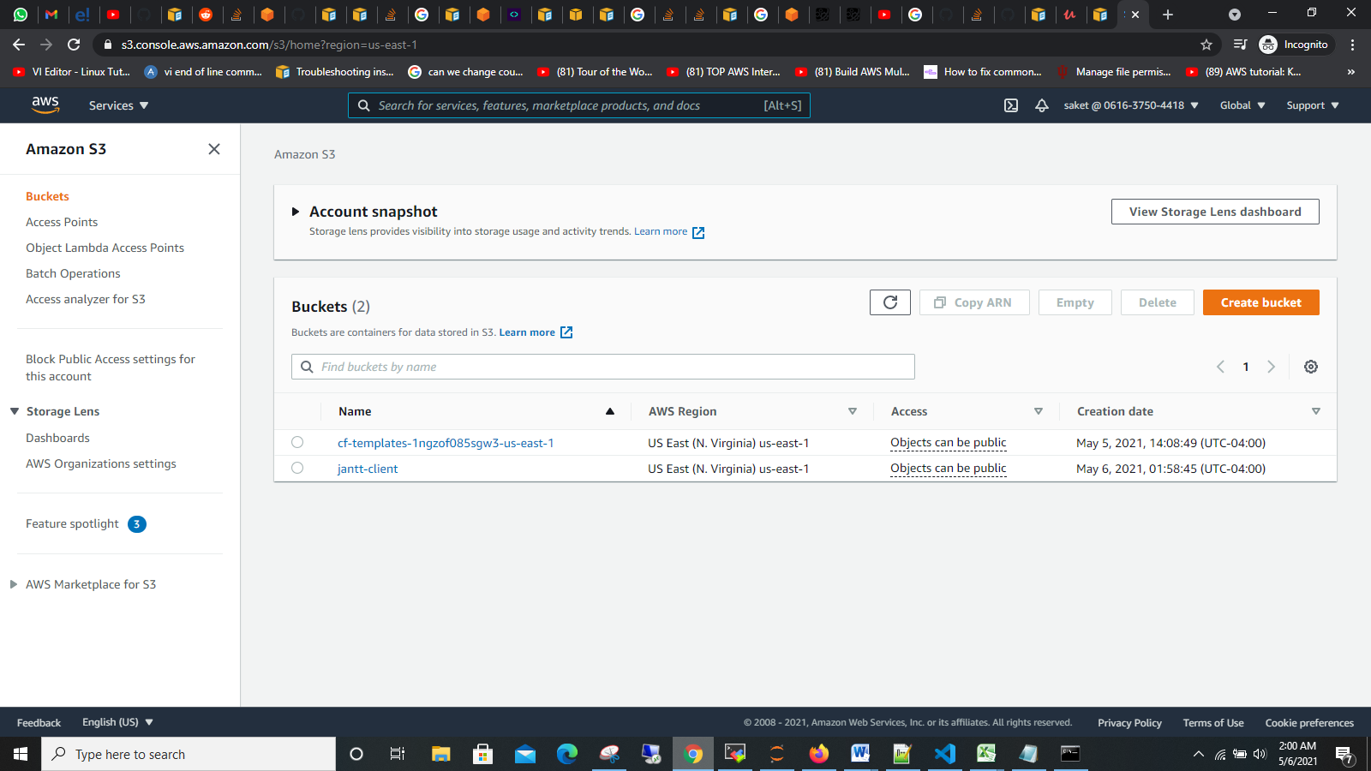

**Step 7: In s3 service we have properties in that we can see region is created as Amazon Resource Name(ARN) and creation date.**

